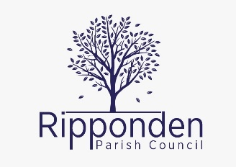

Scheme of Delegation
The Council’s Scheme of Delegation authorises the Clerk to the Council and the Responsible Finance Officer to act with delegated authority in specific circumstances detailed.

Proper Officer and Responsible Finance Officer
- To take act on any issue of such urgency that cannot wait until the next Council meeting. If circumstances permit, the Clerk would normally be expected to consult the Chairman and take his/her view into account.
- To incur expenditure on behalf of the Council which is necessary to carry out any repair, replacement or other work which is of such urgency that it must be done at once, whether there is any budgetary provision for the expenditure subject to the limit of £500.
- Specifically authorised to:
  - Receive declarations of interest.
  - Receive and record notices disclosing pecuniary interests.
  - Receive and retain documents for the Parish Council.
  - Sign Notices and other documents on behalf of the Parish Council.
  - Sign Summons to attend meetings of the council.
  - To be responsible for the Parish Council’s petty cash.
- Delegated authority to undertake the following matters:
  - Day to day administration of services, together with routine inspection and control.
  - Authorisation to call any extra meetings of the Council or any Committee as necessary, having consulted with the Chairman of the Council and/or Chairman of the appropriate Committee.
  - Authorisation to respond immediately to any correspondence requiring or requesting information or relating to previous decisions of the Council, but not to correspondence requiring an opinion to be taken by the Council or its Committees.
Delegated actions of the Clerk to the Council shall be in accordance with Standing Orders, Financial Regulations, and this Scheme of Delegation and in line with directions given by the Council from time to time.

Council
The following matters are reserved to the Council for decision, notwithstanding that the appropriate Committee(s) may make recommendations thereon for the Council’s consideration.
- Setting the precept.
- Borrowing money.
- Approval of the Council’s Annual Accounts and completion of the Annual Return.
- Making, amending, or revoking Standing Orders, Financial Regulations or this Scheme of Delegation.
- Making of Orders under statutory powers.
- Matters of principle or policy.
- Nomination of representatives of the Council to any other authority, organisation, or body (excepting approved Conferences or meetings).
- Any proposed new undertaking.
- Prosecution or defence in a court of law.
- Nomination or appointment of representatives of the Council at any inquiry on matters affecting the Parish, excluding those matters specific to a committee.

Version dates
This new version of the Scheme of Delegation replaced the Scheme of Delegation included in the Standing Orders of 29/3/2022.
Adopted: 14/12/2023: R 18966, page 6820

