To all Members of the Ripponden Parish Council Standards Committee

You are hereby summoned to attend the adjourned Standards Committee Meeting (held on 30 August 2023) which will be held at Ryburn United Football Club on Thursday 12 October at 7.15pm for the purpose of transacting the following business.

1. To accept apologies for absence and lateness

2. To continue with the agenda from the adjourned meeting of 30 August 2023.

3. To decide the date of the next meeting
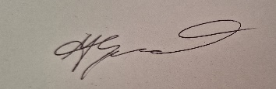
Cllr Alex Greenwood
Chair of Standards Committee
5th October 2023

07918 693383

