To all Members of the Ripponden Parish Council Standards Committee

You are hereby summoned to attend the adjourned Standards Committee Meeting (held on Thursday 17th August 2023) which will be held at Ryburn United Football Club on Wednesday 30th August at 7.15pm for the purpose of transacting the following business.

1. To accept apologies for absence and lateness

2. To approve the minutes of the adjourned meeting held on 17th August 2023
3. To discuss Matters Arising from the previous meeting
4. To discuss, amend and recommend any changes to Financial Regulations to Full Council
5. To discuss, amend and recommend any changes to the Risk Assessment to Full Council
6. To review the Asset Register
7. To discuss, amend and recommend any changes to the Four-Year Plan to Full Council
8. To review the Publication Scheme
9. To discuss a Scheme of Delegation
9. Any other business
10. Date of next meeting
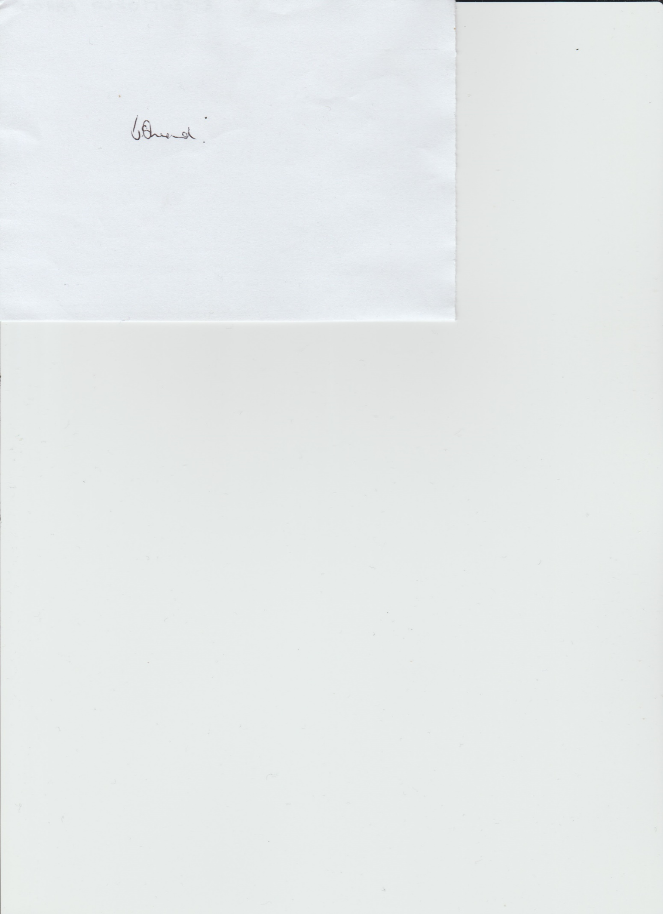

Janet Sheard
Acting Clerk 24th August 2023

07918 693383

