To all Members of the Ripponden Parish Council Standards Committee

You are hereby summoned to attend the reconvened Standards Committee Meeting (held on Thursday 3rd August 2023) which will be held at Ryburn United Football Club on Thursday 17th August at 7.45pm for the purpose of transacting the following business.

1. To accept apologies for absence and lateness

2. To approve the minutes of the adjourned meeting held on 3rd August 2023
3. To discuss Matters Arising from the previous meeting

6. To continue to discuss, amend and recommend any changes to Standing Orders to Full Council
7. To discuss, amend and recommend any changes to Financial Regulations to Full Council
8. To discuss, amend and recommend any changes to the Risk Assessment to Full Council
9. To review the Asset Register
10. To discuss, amend and recommend any changes to the Four-Year Plan to Full Council
11. To review the Publication Scheme
12. Any other business
13. Date of next meeting
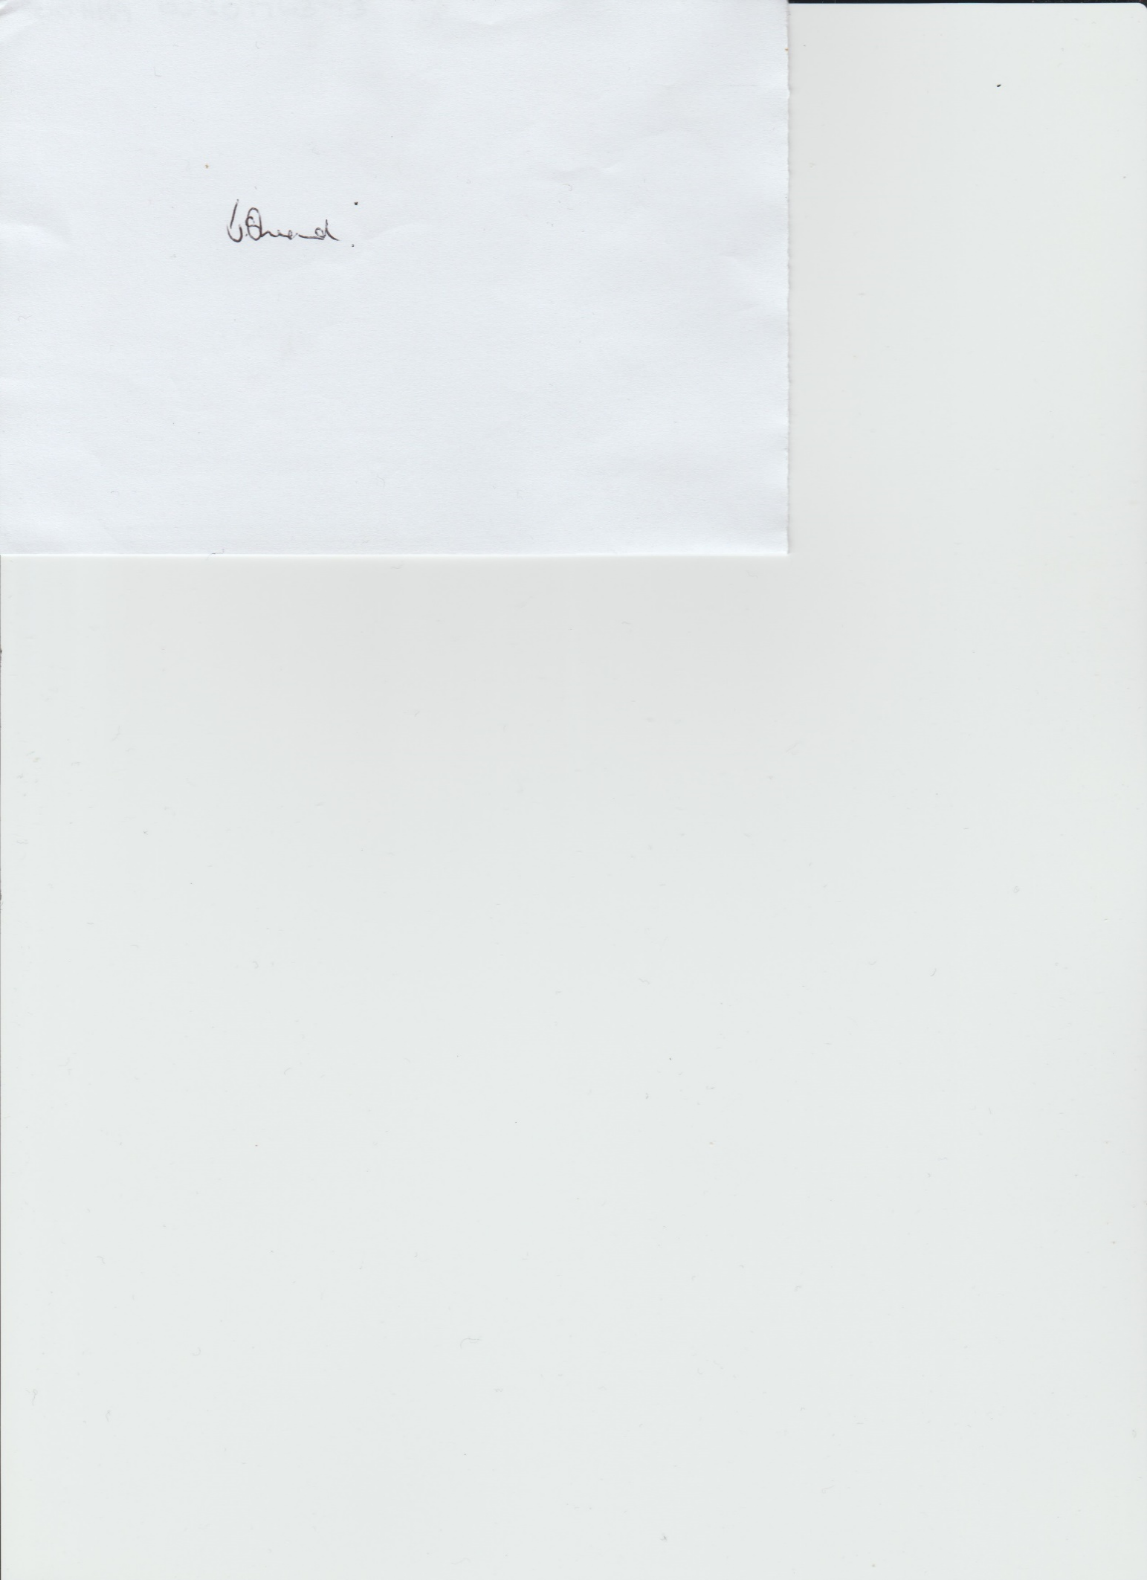

Janet Sheard
Acting Clerk 11th August 2023

07918 693383

