To all Members of the Ripponden Parish Council Standards Committee

You are hereby summoned to attend a Standards Committee Meeting to be held at Ryburn United Football Club on Thursday 3rd August 2023 at 7.15pm for the purpose of transacting the following business.

1. To elect a Chairman for 2023/2024
2. To accept apologies for absence and lateness
The Acting Clerk should be informed of any reasons for lateness/ absence within a reasonable timeframe.

3. To approve the minutes of the meeting held on 21st March 2023
4. To discuss Terms of Reference of the Standards Committee
5. To discuss Matters Arising from the previous meeting

6. To discuss, amend and recommend any changes to Standing Orders to Full Council
7. To discuss, amend and recommend any changes to Financial Regulations to Full Council
8. To discuss, amend and recommend any changes to the Risk Assessment to Full Council
9. To review the Asset Register
10. To discuss, amend and recommend any changes to the Four-Year Plan to Full Council
11. To review the Publication Scheme
12. Any other business
13. Date of next meeting
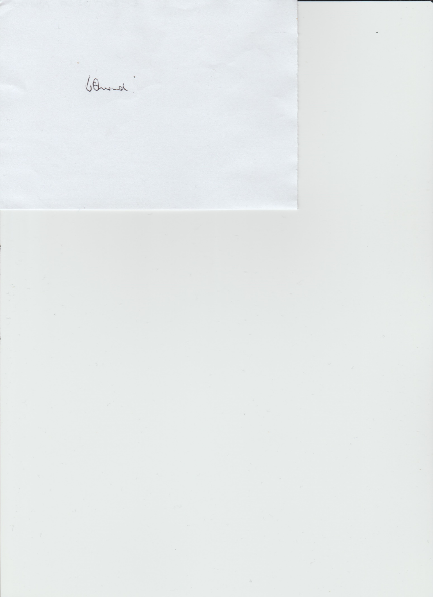

Janet Sheard
Acting Clerk 31st July 2023

07918 693383

