To all Members of the Ripponden Parish Council Environment Committee

You are hereby summoned to attend an Environment Committee Meeting to be held at Ryburn United Football Club on Thursday 14 March 2024 at 7.15pm for the purpose of transacting the following business.

- To accept apologies for absence and lateness.

- To discuss matters arising from the previous meeting.
  - To receive an update on conversations with Andrew Pitts regarding improvements to parish War Memorials and any other sites for identified improvement.
  - To receive an update on noticeboard replacement / renovation.
  - To receive an update on Pretoria Bridge.

- To finalise details on the 2024 garden competition, confirm the judges and make a final decision on categories and publicity.

- To receive an update on prospective quotes from landscapers regarding Rishworth War Memorial.

- To receive an update on the allocation and distribution of dog poo waste bags.

- To hear reports from councillors and co-opted members.

- To discuss the idea of resurrecting a Ripponden Parish Council organised and sponsored market.

- To discuss progress with the K9 telephone box on Rochdale Road.

- To discuss Cllr Whitworth’s suggestion of repainting the milestone opposite the Lion Pub on Halifax Road.

- To agree a date for the next meeting.

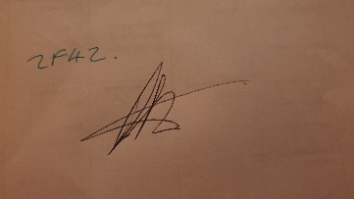

Cllr Peter Hunt
Chair of Environment Committee

