To all Members of the Ripponden Parish Council Environment Committee

You are hereby summoned to attend an Environment Committee Meeting to be held at Ryburn United Football Club on Thursday 18th January 2024 at 7.15pm for the purpose of transacting the following business.

- To accept apologies for absence and lateness.
- To review the Environment budget for 23/24.
  - Horticultural goods and services: £2000
  - Ebenezer Graveyard and Hob Lane mow: £543
  - Ebenezer Graveyard maintenance: £532
  - CROWS annual maintenance: £500
  - Garden competition: £100
  - Dog waste bags: £300
  - Odd job man: £800
- To review the reserves for environment committee projects.
  - Noticeboard replacement: £640
  - Playground repair: £2000
  - Replant memorials/renovate horticultural sites: £4000
  - Telephone box repair: £1500
  - Playground equipment: £7000
  - Public space railings: £10000
- To discuss matters arising from the previous meeting.
  - To receive an update on the Ripponden War Memorial railing situation and decide upon action to be taken.
  - To discuss plans for the K6 telephone box on Rochdale Road and decide to be taken.
  - To receive an update on Pretoria Bridge.
- To discuss the 2024 garden competition and decide upon categories (considering new biodiversity policy requirements), publicity, judges, deadlines, and awards/prizes.
- To discuss and agree upon action to be taken on the back section of the Rishworth War Memorial Garden, and whether displaced shrubs can be used elsewhere.
- To discuss the Rishworth turning circle island and decide upon any improvements to be made.
- To receive an update on plans for new playground equipment.
- To decide upon quantity of dog waste bin bags to purchase.
- To identify odd jobs to be undertaken in 24/25 and discuss the requirement for an odd job man.
- To discuss and decide upon action to be taken on the replacement of noticeboards.
- To identify possible sites in Boothwood, Krumlin, Kebroyd and Lighthazels for possible horticultural improvement.
- To hear reports from councillors and co-opted members.
- To agree a date for the next meeting.

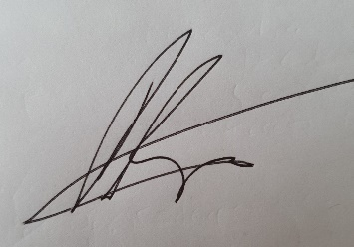

Peter Hunt
Chair of Environment Committee

