To all Members of the Ripponden Parish Council Environment Committee

You are hereby summoned to attend an Environment Committee Meeting to be held at Ryburn United Football Club on Tuesday 25th July 2023 at 7.15pm for the purpose of transacting the following business.

1. To elect a Chairman for 2023/2024
2. To accept apologies for absence and lateness

3. To approve the minutes of the meeting held on 14th March 2023
4. To discuss Terms of Reference of the Environment Committee
5. To discuss the appointment of co-opted members for 2023/2024

6. Matters Arising from the previous meeting
7. To discuss the Committee budget and expenditure
8. To discuss the purchase of railings for the Ripponden War Memorial
9. To discuss the damage to and repair of the K6 telephone box on Rochdale Road
10. To discuss the provision of play equipment at the Rishworth play area
11. To discuss the replanting of the War Memorials
12. Date of next meeting
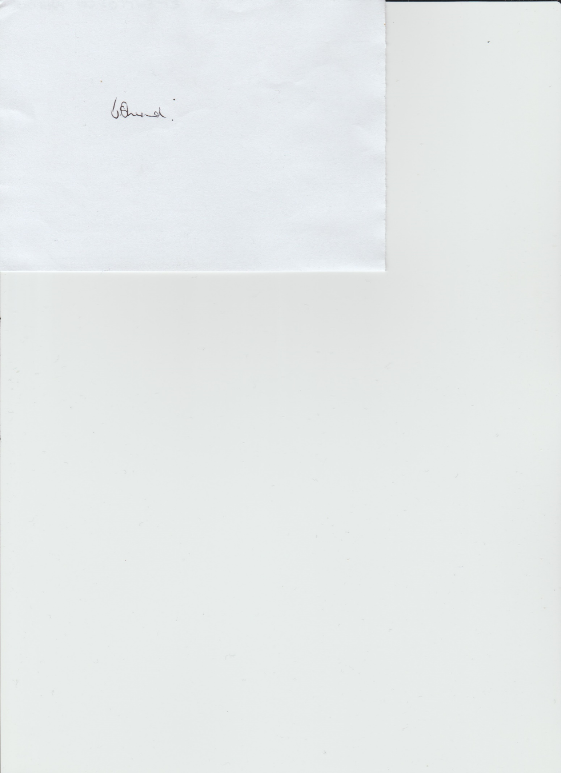

Janet Sheard
Acting Clerk

07918 693383

