To all members of the Ripponden Parish Council Employment Committee.

You are hereby summoned to attend the meeting of the Ripponden Parish Council Employment Committee to be held at Ryburn United Football Club, Ripponden on Tuesday 26th September 2023 at 7.00pm for the purpose of transacting the following business.

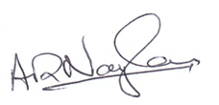

Signed Cllr A Naylor, Chairman 20/09/23

AGENDA

1. To accept apologies for lateness or absence.
2. To approve the minutes of the Extraordinary Meeting of Ripponden Parish Council Employment Committee held on 17th August 2023.
3. To agree Terms of Reference of Employment Committee.
4. To discuss appointment of Clerk/ RFO to the Ripponden Parish Council.